**SRM CLASS ROOMS AND MANAGEMENT SYSTEM (CRMS)**

Project submitted to the

SRM University – AP,Andhra Pradesh

For the partial fulfilment of the requirements to award the degree of

**BACHELOR OF TECHNOLOGY**

In

**Computer Science and Engineering**

**School of Engineering and Sciences**

**Submitted by: GROUP-8**

P CHARAN VARMA[AP21110010759]



Under the guidance of

**BHASKARA SANTHOSH**

SRM University–AP

Neerukonda, Mangalagiri, Guntur

Andhra Pradesh – 522 240

[DEC, 2022]

# 

# Certificate

Date: 15-Dec-22

This is to certify that the work present in this Project entitled **“SRM CLASS**

**ROOMS MANAGEMENT SYSTEM(CRMS)”** has been carried out by

[GROUP-8] under our supervision. The work is genuine, original, and suitable for submission to the SRM University – AP for the award of Bachelor of Technology in School of Engineering and Sciences.

**Supervisor**

BHASKARA SANTHOSH

SRM University ,AP.

# ACKNOWLEDGEMENTS

With a deep sense of gratitude, we wish to express my sincere thanks to my guides, **BHASKARA SANTHOSH** for giving us the opportunity to work under them on the project. We truly appreciate and value their esteemed guidance and encouragement from the beginning to end of this project. We are extremely grateful to him. We want to thank to my lecturers for providing a solid background for our studies and project thereafter. They have been great source of inspiration to us. We also want to thank our parents, who taught us the value of hard work by their own example. we would like to thank our department for giving us the opportunity and platform to make our effort a successful one.

# Table of Contents:

1. Abstract
2. Introduction
3. Flowchart
4. Program
5. Output
6. Conclusion

**ABSTRACT**

Classroom and lab management system, that maintains all class details.

It displays the details of the class or lab going in that particular room based on the allotment. Also, it will display vacant room numbers with their seating capacity for booking.

If Any faculty need a room at that particular time can book a room based on the class requirement. Lastly, lab assistants and faculty can add a note based on their findings in that room such as power issues, infrastructural issues, or equipment issues for resolution.

# INTRODUCTION

# Class room and lab management system is a software that can maintain all

# the class and lab details. It helps in academic planning group in assigning

# rooms and labs for a regular schedule.

# FLOW CHART

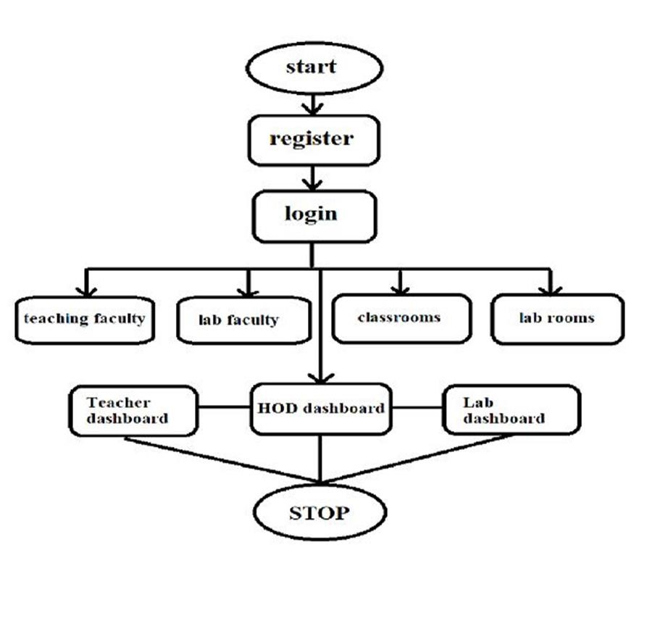

**PROGRAM**

#include <bits/stdc++.h>

using namespace std;

int validate_email(string email) // ! status : checked

{

if (email.length() > 13) // ! @srmap.edu.in - length is 13

{

int n = email.find('@');

if (n != 0)

{

int _ = 0;

for (int i = 0; i < n; i++)

{

if (email[i] < 'a' || email[i] > 'z')

{

if (email[i] == '_' && _ != 1)

_ += 1; // ! only one '_' is allowed

else

return 0;

}

}

if (email.substr(n + 1) == "srmap.edu.in")

return 1;

return 0;

}

else

return 0;

}

else

return 0;

}

string is_there(string log, string user_name) // ! status : checked

{

ifstream file(log);

string x; // ! checking if user already exist or not

while (file)

{

getline(file, x);

if (x.substr(0, x.find(' ')) == user_name)

{

file.close();

return x;

}

}

file.close();

return "0";

}

string user_login(int x = 1) // ! status = checked

{

string user_name, password;

string log;

if (x == 1)

log = "admin_password_log.txt";

else

log = "password_log.txt";

do

{

int n;

if (x == 1)

{

cout << "\t\t\t\t========================================================================" << endl;

cout << "\t\t\t\t| |" << endl;

cout << "\t\t\t\t| 1.Register |" << endl;

cout << "\t\t\t\t| 2.Login |" << endl;

cout << "\t\t\t\t| 3.Exit |" << endl;

cout << "\t\t\t\t| |" << endl;

cout << "\t\t\t\t========================================================================" << endl;

cout << "\t\t\t\tEnter choice : ";

cin >> n;

}

else

{

cout << "\t\t\t\t========================================================================" << endl;

cout << "\t\t\t\t| |" << endl;

cout << "\t\t\t\t| 1.Login |" << endl;

cout << "\t\t\t\t| 2.Exit |" << endl;

cout << "\t\t\t\t| |" << endl;

cout << "\t\t\t\t========================================================================" << endl;

cout << "\t\t\t\tEnter choice : ";

cin >> n;

n++;

}

switch (n)

{

case 1:

{

fflush(stdin);

cout << "\t\t\t\tEnter email id : ";

getline(cin, user_name);

if (validate_email(user_name))

{

if (is_there(log, user_name) == "0")

{

string x;

do

{

cout << "\t\t\t\tEnter password ( min 8 characters ): ";

getline(cin, password);

if (password.length() >= 8)

{

cout << "\t\t\t\tConform your password : "; // ! reverifying password

getline(cin, x);

if (x != password)

cout << "\t\t\t\t\t\t- password not matched re enter again -\n";

else

break;

}

else

cout << "\t\t\t\t\t\t!!!!! ~ password length must be minimum 8" << endl;

} while (1);

cout << "\n\t\t\t\t\t\t --- you are successfully registered ---\n\n";

ofstream file(log, ios::app);

file << user_name + " " + password << endl; // ! adding new user into log

file.close();

}

else

cout << "\t\t\t\t\t\tUser already exist......!/#$%^*()" << endl;

}

else

cout << "\t\t\t\t\t\tInvalid username......!/#$%^*()\n";

break;

}

case 2:

{

ifstream file(log);

fflush(stdin);

cout << "\t\t\t\tEnter email id : ";

getline(cin, user_name);

cout << "\t\t\t\tEnter password : ";

getline(cin, password);

if (validate_email(user_name))

{

string x = is_there(log, user_name);

if (x != "0")

{

x = x.substr(x.find(' ') + 1);

if (x == password)

return user_name;

else

cout << "\t\t\t\t\t\tIncorrect password......!/#$%^*()" << endl;

}

else

cout << "\t\t\t\tuser does not exist......!/#$%^*()" << endl;

}

else

cout << "\t\t\t\tInvalid username and password......!/#$%^*()\n";

break;

}

case 3:

return "-";break;

}

} while (1);

}

class time_slot // ! status = checked

{

string name, sub, sec;

public:

int vacant;

time_slot()

{

vacant = 1;

}

void book_slot(string x, int s, int e, string str)

{

name = x;

cout << "\t\t\t\tEnter subject name : ";

fflush(stdin);

getline(cin, sub);

fflush(stdin);

cout << "\t\t\t\tEnter section : ";

getline(cin, sec);

ifstream check(sec + ".txt");

if (check)

{

while (!check.eof())

{

string temp;

getline(check, temp);

temp = temp.substr(0, temp.find(' '));

if (temp == to_string(s) + "-" + to_string(e))

{

cout << "\t\t\t\t\tThis section is already having a class in same slot" << endl;

check.close();

return;

}

}

}

check.close();

name += ".txt";

ofstream file(name, ios::app);

ofstream m(sec + ".txt", ios::app);

file << to_string(s) + "-" + to_string(e) + " " + sub + " " + sec + " " + str << endl;

m << to_string(s) + "-" + to_string(e) << " " << str << " " << name.substr(0, name.find('.')) << " " << sub << endl;

file.close();

m.close();

vacant = 0;

cout << "\t\t\t\t\t\t-------------Slot booked------------" << endl;

}

};

class class_room

{

int available;

public:

time_slot t[8];

class_room()

{

available = 1;

}

int found(string name, string s)

{

ifstream file(name + ".txt");

string a;

while (file)

{

getline(file, a);

if (a.substr(0, a.find(' ')) == s)

return 1;

}

file.close();

return 0;

}

void book(string str)

{

if (available)

{

string name, sub, sec;

int s, e;

cout << "\t\t\t\tEnter start time : ";

cin >> s;

cout << "\t\t\t\tEnd time : ";

cin >> e;

if (s >= 1 && s <= 5)

s += 12;

if (e >= 1 && e <= 5)

e += 12;

if ((s >= 9 && s <= 17) && (e >= 9 && e <= 17) && (e - s) == 1)

{

int i = s % 9;

if (s > 12 && s <= 17)

s -= 12;

if (e > 12 && e <= 17)

e -= 12;

if (t[i].vacant)

{

up:

fflush(stdin);

cout << "\t\t\t\tEnter lecturers name : ";

getline(cin, name);

if (is_there("password_log.txt", name + "@srmap.edu.in") != "0")

{

if (found(name, to_string(s) + "-" + to_string(e)))

{

cout << "\t\t\t\t oops!! '" + name + "' " + " has another lecture in the same slot\n";

goto up;

}

else

t[i].book_slot(name, s, e, str);

}

else

{

cout << "\t\t\t\tLecturer not found\n";

cout << "\t\t\t\tDo you want to add this lecturer\n\t\t\t\tEnter '1' ~ else '0' : ";

int n;

cin >> n;

if (n)

{

ofstream file("password_log.txt", ios::app);

file << name + "@srmap.edu.in"

<< " " << name << endl;

file.close();

t[i].book_slot(name, s, e, str);

}

else

{

cout << "\n\t\t\t\tEnter again\n"

<< endl;

goto up;

}

}

}

else

cout << "\t\t\t\t\t\tTime slot is already booked" << endl;

}

else

cout << "\t\t\t\t\t\t Inavlid time slot" << endl; // !Only 1hr duration class can be added

}

else

cout << "\t\t\t\t\t\tRoom un available";

}

int check_availability(int s)

{

if (t[s % 9].vacant)

return 1;

return 0;

}

};

class_room room[50];

int slot_display(string x, int p)

{

string y;

int count = 0;

ifstream file(x + ".txt");

if (file)

{

while (!file.eof())

{

getline(file, y);

if (y.length() != 0)

{

count++;

if (p)

cout << count << endl;

cout << "\t\t\t\tTime slot : " << y.substr(0, y.find(' ')) << endl;

y = y.substr(y.find(' ') + 1);

cout << "\t\t\t\tSubject : " << y.substr(0, y.find(' ')) << endl;

y = y.substr(y.find(' ') + 1);

cout << "\t\t\t\tSection : " << y.substr(0, y.find(' ')) << endl;

y = y.substr(y.find(' ') + 1);

cout << "\t\t\t\troom no : " << y.substr(0, y.find(' ')) << endl;

if (p == 2)

{

y = y.substr(y.find(' ') + 1);

cout << "\t\t\t\tRemarks : " << y << endl;

}

cout << "\t\t\t\t---------------------------------------------------------" << endl;

}

}

return count;

}

else

cout << "\t\t\t\tNo classes found" << endl;

return 0;

}

void Admin_login()

{

string x = user_login();

if (x != "-")

{

int n;

do

{

cout << "\t\t\t\t ========================================================================" << endl;

cout << "\t\t\t\t| |" << endl;

cout << "\t\t\t\t| 1 . Assign a class |" << endl;

cout << "\t\t\t\t| 2 . Add a lecturer |" << endl;

cout << "\t\t\t\t| 3 . Check available room |" << endl;

cout << "\t\t\t\t| 4 . Get section wise time table |" << endl;

cout << "\t\t\t\t| 5 . Logout |" << endl;

cout << "\t\t\t\t| |" << endl;

cout << "\t\t\t\t ========================================================================" << endl;

cout << "\n\t\t\t\tEnter choice : ";

cin >> n;

switch (n)

{

case 1:

{

int x, y, z;

do

{

cout << "\t\t\t\tEnter room number : ";

cin >> n;

if ((n > 100 && n < 106) || (n > 200 && n < 206) || (n > 300 && n < 306) || (n > 400 && n <406) || (n > 500 && n <506))

{

x = n % 10;

y = n / 100;

z = (n / 10) % 10;

if (z == 1)

x = 10;

y = (y - 1) * 10 + (x - 1);

break;

}

else

cout << "\t\t\t\t\t\t\t\t---Invalid room number---" << endl;

} while (1);

room[y].book(to_string(n));

break;

}

case 2:

{

string name;

cout << "\t\t\t\tEnter lecuter name : ";

fflush(stdin);

getline(cin, name);

if (is_there("password_log.txt", name + "@srmap.edu.in") == "0")

{

ofstream file("password_log.txt", ios::app);

file << name + "@srmap.edu.in" + " " + name << endl;

file.close();

}

else

cout << "\t\t\t\t\t\t\t\t-----Lecturer already exists----" << endl;

break;

}

case 3:

{

int s, e;

cout << "\t\t\t\tEnter start time : ";

cin >> s;

cout << "\t\t\t\tEnter end time : ";

cin >> e;

for (int i = 0; i < 50; i++)

{

if (room[i].check_availability(s))

{

int x = i / 10, y = i % 10;

if (y == 9)

cout << "\t\t\t\t" << (x + 1) * 100 + 10 << endl;

else

cout << "\t\t\t\t" << (x + 1) * 100 + (y + 1) << endl;

}

}

break;

}

case 4:

{

string x;

cout << "\t\t\t\tEnter section name : ";

fflush(stdin);

getline(cin, x);

ifstream op(x + ".txt");

if (op)

{

while (!op.eof())

{

getline(op, x);

if (x.length() != 0)

{

cout << "\t\t\t\tTime : " << x.substr(0, x.find(" ")) << endl;

x = x.substr(x.find(" ") + 1);

cout << "\t\t\t\tRoom no : " << x.substr(0, x.find(" ")) << endl;

x = x.substr(x.find(" ") + 1);

cout << "\t\t\t\tLecturer name : " << x.substr(0, x.find(" ")) << endl;

x = x.substr(x.find(" ") + 1);

cout << "\t\t\t\tSubject : " << x << endl;

cout << "\t\t\t\t--------------------------------------------------------------------" << endl;

}

}

op.close();

}

else

cout << "\t\t\t\tSection not found" << endl;

break;

}

case 5:

return;

default:

break;

}

} while (1);

}

}

void Lecturer_login()

{

string x = user_login();

x = x.substr(0, x.find('@'));

if (x != "-")

{

int n;

do

{

cout << "\t\t\t\t ========================================================================" << endl;

cout << "\t\t\t\t| |" << endl;

cout << "\t\t\t\t| 1 . Check Schedule |" << endl;

cout << "\t\t\t\t| 2 . Logout |" << endl;

cout << "\t\t\t\t| |" << endl;

cout << "\t\t\t\t ========================================================================" << endl;

cout << "\n\t\t\t\tEnter choice : ";

cin >> n;

switch (n)

{

case 1:

{

int c = slot_display(x, 0);

cout << "\t\t\t\tToday lectures : " << c << endl;

break;

}

case 2:

cout << "\t\t\t\t\t\t\t\tSuccesfully logged out" << endl;

return;

default:

break;

}

} while (1);

}

}

int main()

{

int n;

do

{

cout << "\t\t\t\t========================================================================" << endl; cout << "\t\t\t\t| - WELCOME TO SRM CLASSROOM MANAGEMENT SYSTEM - |" << endl;

cout << "\t\t\t\t| |" << endl;

cout << "\t\t\t\t| 1 . Admin login |" << endl;

cout << "\t\t\t\t| 2 . Lecturer login |" << endl;

cout << "\t\t\t\t| 3 . Exit |" << endl;

cout << "\t\t\t\t| |" << endl;

cout << "\t\t\t\t===========================================" << endl;

cout << "\n\t\t\t\tEnter choise : ";

cin >> n;

switch (n)

{

case 1:

Admin_login();

break;

case 2:

Lecturer_login();

break;

case 3:

cout << "\t\t\t\tThank_you";

return 0;

default:

cout << "\t\t\t\tEnter dispalyed choices only\n";

}

} while (1);

return 0;

}

**Output:**

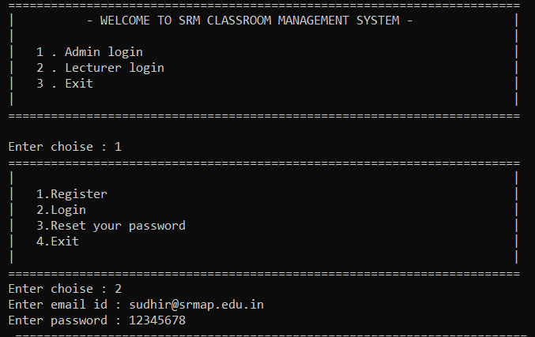

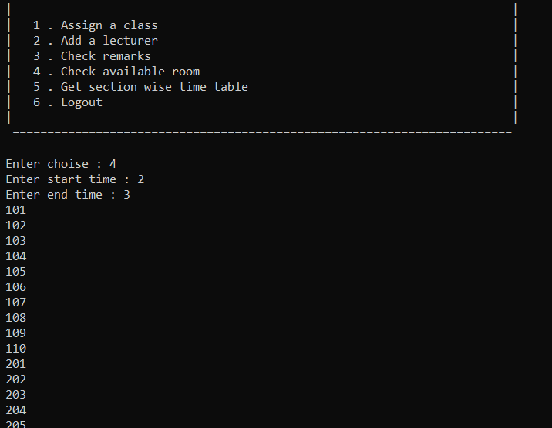

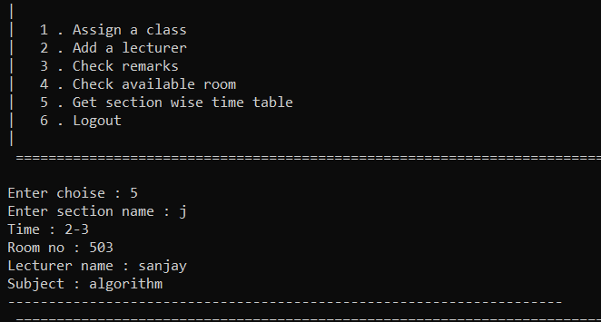

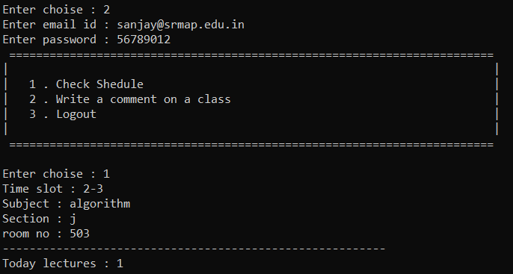

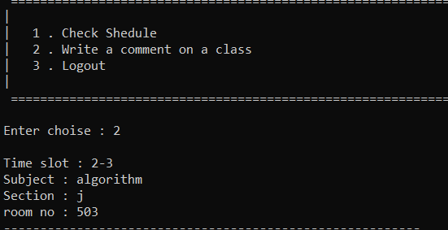

**CONCLUSION**

Classroom and Lab Management system can be beneficial to students interested

learning the C++ programming language. As it makes the classroom and lab

management easy to organize not just for the students but also to the management

of the concerned organizations.